GESNER STREET ELEMENTARY SCHOOL
2022-23
GRADE 2 SUPPLY LIST
English & French Immersion

When sending in school supplies please make sure the bag containing the school supplies is labeled with your child’s name.

Please purchase the following items for your child to start the school year:
PLEASE ONLY LABEL:
- Lunch Box
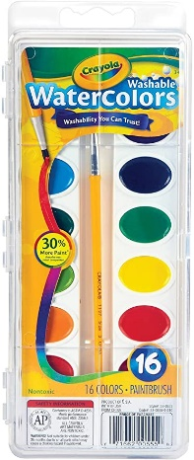
- Backpack
- Pair of indoor VELCRO sneakers (for gym)
*NO BLACK SOLES OR LACES (laces on sneakers do not stay tied and can become a safety concern for the little ones).
1 Pair of scissors
1 Crayola Watercolor Paint Set

PLEASE DO NOT LABEL:
3 Large glue sticks (big yellow ones preferred)
1 Pkg (24) Crayola crayons
1 Pkg (24) Crayola pencil crayons (sharpened)
1 Pkg (8) broad lined Crayola washable markers. (unscented)
3 Hilroy 72 Page Exercise Books (Yellow, 1/2 plain,1/2 lined)
5 Duotangs (1 red, 1 green, 1 blue, 1 yellow, 1 orange)
20 Clear Plastic Page Protectors (available at the Dollar Store)
2 boxes of Kleenex
2 Pkgs. HB2 Staedtler Norica Pencils (blue) are preferred
3 White vinyl erasers
12 BLACK Expo Dry Erase Markers
- BLACK Sharpie markers (fine tip)
1 BLACK Sharpie markers (ultra fine tip)
1 box large zip-loc bags
1 box small zip-lock bags

Please place a tag on your child’s backpack indicating their name and address, as well as bus numbers for AM and PM Mon-Thurs and bus numbers for AM and PM for Friday.
Agendas, containing the school handbook, have been ordered for each student at a cost of $10.00 .
*Additional supplies maybe requested throughout the year.

